_____1. All of these are natural events that could alter an ecosystem EXCEPT:
A burning of fossil fuels
B wildfires
C floods
D volcanic activity
_____2. Which of these best describes an organism’s ability to maintain the constant internal conditions necessary for life?
A Homeostasis
B Stability
C Reproduction
D Adaptation
_____3. Gametes must be haploid because:
A gametes are small and can hold only the haploid number of chromosomes
B the gametes’ chromosomes will be replicated prior to cell division
C two gametes will unite during fertilization to create a diploid cell
D fertilization results with a haploid zygote
_____4. Overheating an enzyme results in the enzyme’s loss of:
A net electrical charge
B ability to catalyze a reaction
C storage of a large amount of chemical energy
D storage of inherited information
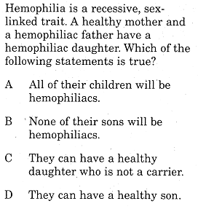
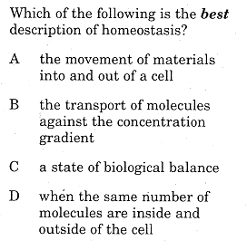
_____5. _____6.

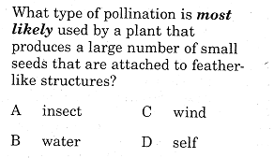
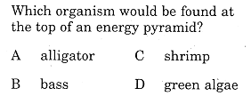
_____7. _____8.

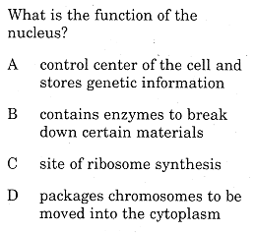
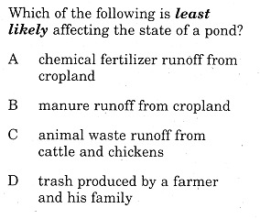
_____9. _____10.

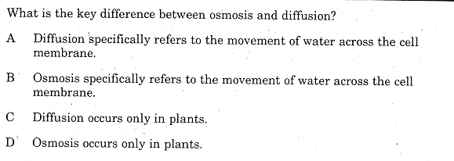
_____11.

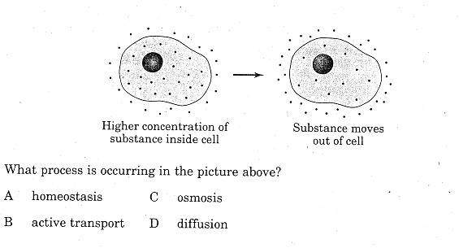
_____12.

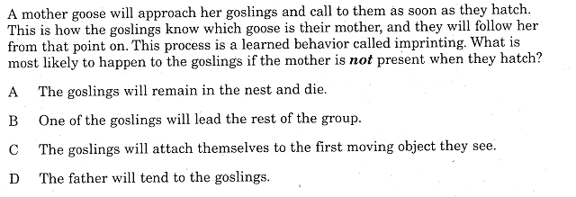
_____13.

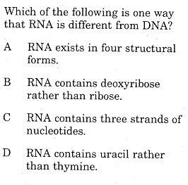
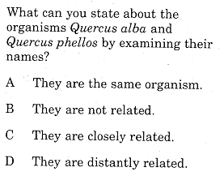
_____14. _____15.

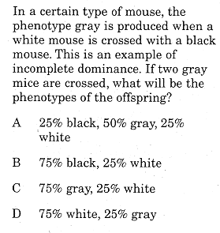
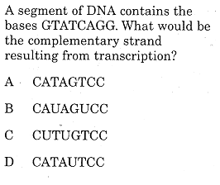
_____16. _____17.

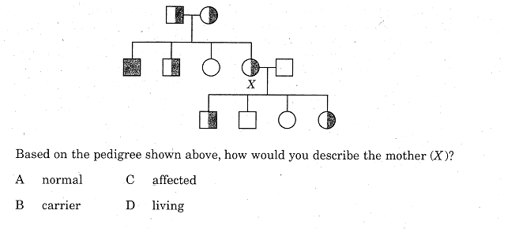
_____18.

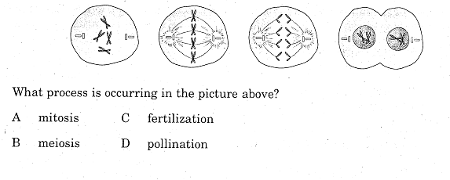
_____19.

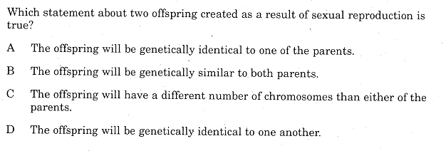
_____20.

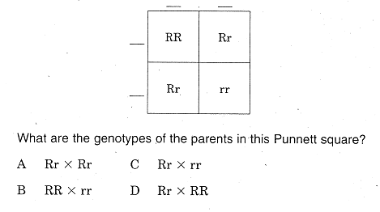
_____21.

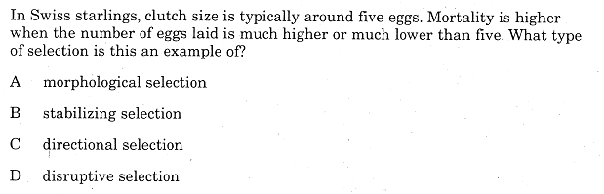
_____22.

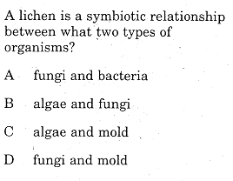
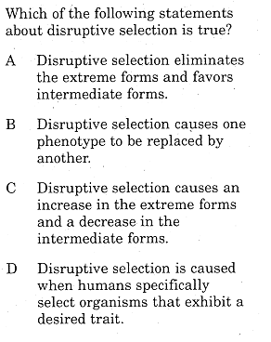
_____23. ______24.

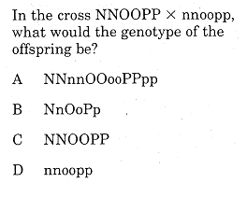
______25.

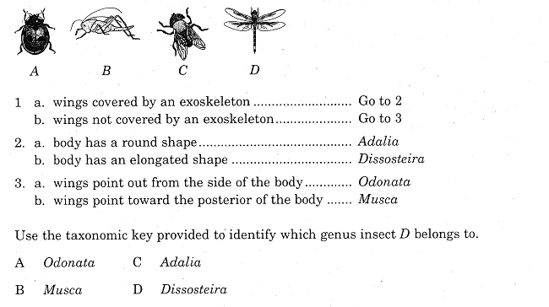
_____26.

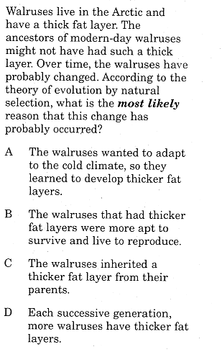
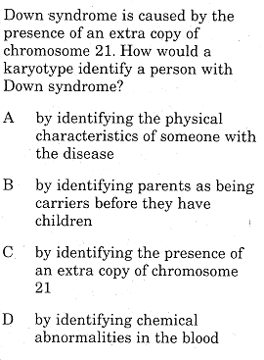
_____27. ________28.

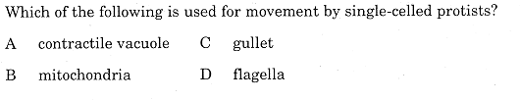
_____29.

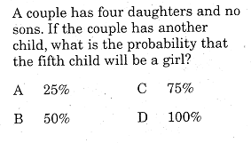
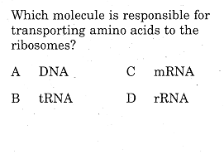
_____30. _____31.

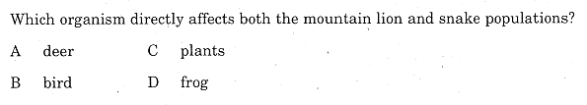
_____32.

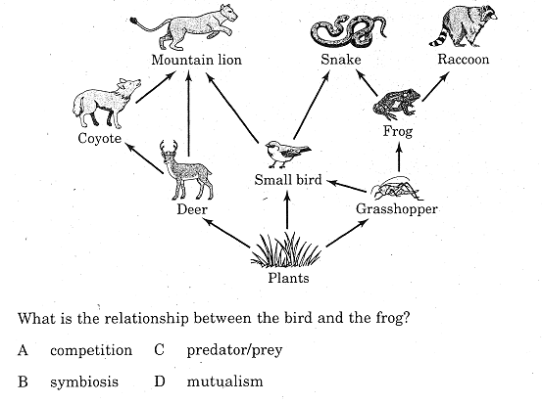
_____33.

.

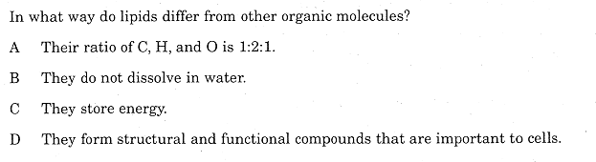
_____34.

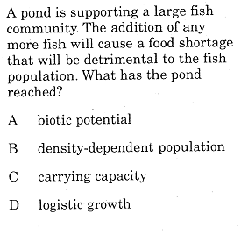
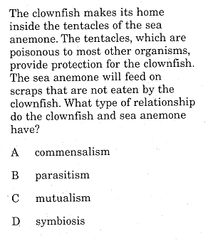
_____35. _______36.

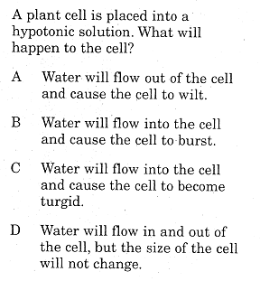
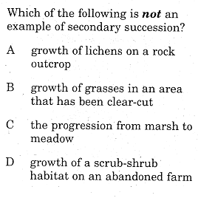
_____37. _____38.

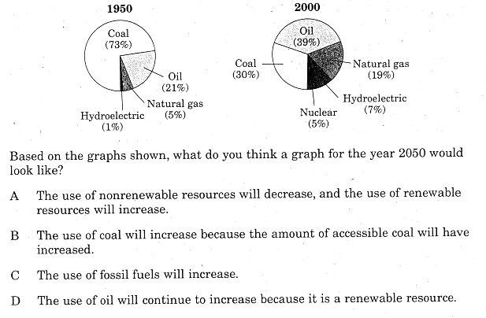
_____39.

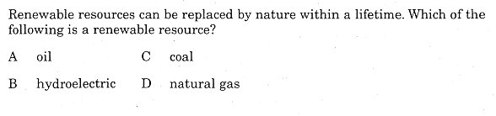
_____40.

