_____1. The dichotomous key is for arthropods.
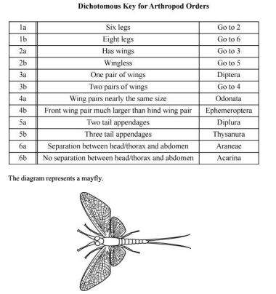
To which order does the mayfly belong?
A. Diptera B. Ephemeroptera C. Odonata D. Thysanura
_____2. The diagram below represents a type of phylogenetic tree called a cladogram.
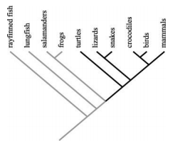
Which organisms are most closely related?

A. turtles and lizards
B. birds and mammals
C. crocodiles and birds
D. lungfish and salamanders

_____3. The diagram below shows the evolutionary relationships among animals with common ancestors.
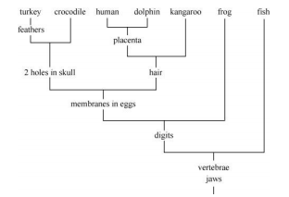
According to this diagram, at least how many homologous structures do turkeys and crocodiles have?

A. one
B. two
C. four
D. five

_____4. Which information would be least useful in determining the classification of an organism?

A. structural analysis
B. where the organism lives
C. how the organism develops
D. DNA and biochemical analysis

_____5. Over a period of a few months, a student learns to ignore the ringing of his alarm clock. Which type of learning behavior has occurred?

A. imprinting
B. habituation
C. trial and error
D. classical conditioning

_____6. What adaptation is most responsible for allowing plants to grow in areas where there is limited water?

A. roots
B. flowers
C. chlorophyll
D. vascular tissues

_____7. Which adaptation is more essential for a heterotrophic multi-cellular organism than for a multi-cellular autotrophic organism?

A. water evaporation
B. cellular respiration
C. means of locomotion
D. asexual reproduction

_____8. Which impact may a quickly rising population have on a developing country?

A. decreased land pollution
B. increased land availability
C. higher potential for disease
D. decreased food consumption

_____9. The graphs below represent possible changes in human population.
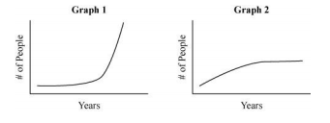
Which conclusion is most accurate?
A. Graph 1’s birth rate is greater than its death rate.
B. Graph 2’s birth rate is greater than its death rate.
C. Graphs 1 and 2 both have greater birth rates than death rates.
D. Graphs 1 and 2 both have roughly equal birth and death rates.
_____10. Which would raise the carrying capacity of the environment for a given species?
A. decreasing the size of the environment
B. introducing contaminants in to the environment
C. increasing water and food supplies in the environment
D. populating the environment with a predator of the species
_____11. The diagram shows an inverted energy pyramid
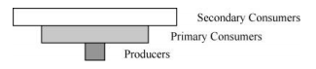
Why do energy pyramids NOT appear like the diagram?
A. Producers outnumber consumers in ecosystems.
B. Heat escapes from lower trophic levels and does not increase.
C. Individual producers contain greater energy than individual consumers.
D. Consumers gain more energy than they lose when consuming other animals
_____12. Which human activities have the greatest impact on the carbon cycle?
A. crop rotation and deforestation
B. cellular respiration and crop rotation
C. deforestation and burning fossil fuels
D. burning fossil fuels and cellular respiration

_____12. The diagram shows one part of a food web.
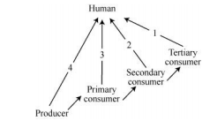
Along which arrow will a human most likely receive the highest proportion of usable energy per biomass consumed?

A. 1
B. 2
C. 3
D. 4

_____13. Which process, marked with an X in the diagram below, is one way that animals put CO2 into the atmosphere?
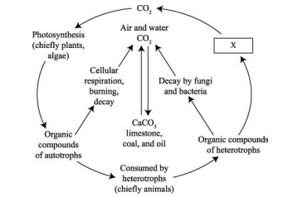

A. combustion
B. photosynthesis
C. respiration
D. transpiration

_____14. Enzymes are:

- proteins
- proteins
- proteins
- proteins

IF YOU DO NOT ANSWER PROTEINS, THERE IS NOTHING I CAN DO FOR YOU.
_____15. Which provides the best argument against the introduction of a non-native animal species to a sensitive ecosystem?
A. The species might be outcompeted by native species.
B. The species may have no natural predators in the new ecosystem.
C. The species may be susceptible to pathogens in the new ecosystem.
D. The species might be unable to produce viable offspring with native species.

