_____1. The Linnaean taxonomic system classifies organisms into divisions called taxa. If two organisms belong to the same taxonomic group, they are related. Similarity at which of these levels indicates the closest relationship?

A Kingdom
B Class
C Order
D Genus

_____2. Sickle-shaped red blood cells result from a mutation in the gene that codes for hemoglobin.
This mutation results in sickle-cell anemia. A partial sequence of bases from a normal hemoglobin gene and a sequence that results in sickle-cell anemia are shown below.
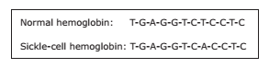
What type of mutation is depicted in this sequence?

A Substitution
B Insertion
C Deletion
D Frameshift

_____3. In Madagascar scientists have discovered a moth, Xanthopan morganii praedicta, that has a 30.5 cm proboscis and feeds from and pollinates Darwin’s orchid,Angraecum sesquipedale.
The orchid has a nectar-producing tube that is 27.9 cm long.
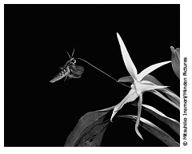
How is the moth’s proboscis size an adaptation for its environment?

A The moth can avoid larger animals.
B The moth can pollinate other flowers.
C The moth has little competition for food.
D The moth has time to feed during the day.

_____4. Telophase is a stage of a cellular process that begins after the chromosomes have moved to opposite poles of the cell. During which cellular process does telophase occur?

A Translation
B Interphase
C Transcription
D Mitosis

_____5. Genome maps provide the DNA sequences of chromosomes. Some scientists have compared the genome maps of a hedgehog and a sloth. What do these genome maps allow the scientists to determine?
A The color patterns of the offspring of each species
B How much the size ranges of the two species differ
C The methods of protein synthesis that each species uses
D How closely related the two species are to each other

_____6. The diagram below represents the nitrogen cycle in a student’s aquarium. Ammonia, nitrites, and, to a lesser degree, nitrates can be harmful to fish. The student wants to keep the nitrogen in this aquarium cycling normally without having to continually change the water.
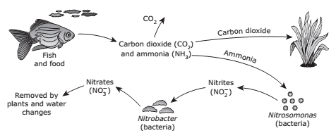
Which of the following should the student add more of to help remove nitrates and improve the natural cycling of nitrogen in this aquarium?

A Fish
B Plants
C Nitrobacter
D Water

_____7. Tomato plants usually have hairy stems. Hairless stems are present in tomato plants that are homozygous recessive for this trait. If the stem characteristics are determined by a single gene, what is the expected outcome of crossing two tomato plants that are heterozygous for hairy stems?

A 75% hairy stems: 25% hairless stems
B 100% hairy stems
C 100% hairless stems
D 50% hairy stems: 50% hairless stems

_____8. Amphibians are dying in large numbers after being infected by an aquatic fungus called
Batrachochytrium dendrobatidis. The origin of this fungus is unknown, but scientists suspect that humans are helping spread it. More than 350 amphibian species have been affected, and at least 200 species of frogs have suffered serious reductions in population or become extinct.

The map below shows the worldwide distribution of B. dendrobatidis.
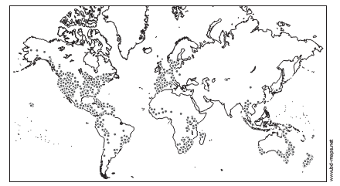
What will be the most likely impact of the decline in frog populations resulting from the fungal infection?
A New species of frogs that feed on both the fungus and the infected species of frogs will evolve.
B Plants will no longer grow in the waters of the affected ecosystems, and fish species will increase.
C The fungus will move on land and destroy reptile and mammal populations in tropical ecosystems.
D Populations of algae and mosquitoes will increase, leading to fish die-offs and potential increases in human malaria cases.

_____9. Which of the following polypeptides is coded for by the mRNA sequence
AUG GUU AAA CGA CAA UCC ?
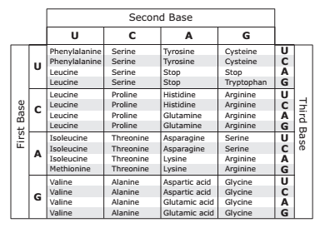

A Val, Lys, Phe, Gly, Ser
B Met, Asp, Phe, Ala, Arg
C Met, Val, Lys, Arg, Gln, Ser
D Ile, Gln, Lys, Asp, Gly, Leu, Ser

_____10. Pepsin and trypsin are two of the digestive enzymes that break down protein. A group of students studied the pH requirements of these enzymes. The graph below shows the results.
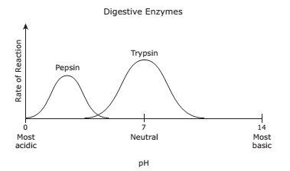
The students found that pepsin functions best in an acid environment and trypsin functions best in a neutral environment. Based on their observations, pepsin most likely aids in digestion in which part of the human body?

A Pancreas
B Intestines
C Mouth
D Stomach

_____11. Which condition is essential for natural selection to result in a new species?

A Unlimited resources
B An inherited variation
C A static environment
D A long life span

_____12. Which of the following biomolecules typically contains both nitrogen and phosphate?

A Lipid
B Protein
C Nucleic acid
D Carbohydrate

_____13. In 1952 Rosalind Franklin took the x-ray photograph shown below, which gave the world its first look at DNA.
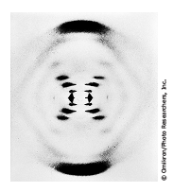
By studying this photograph, scientists gained knowledge about the —

A role of DNA in protein synthesis
B mutation of nucleotide sequences in DNA
C sequence of DNA that makes up the human genome
D double-helix structure of DNA

_____14. The diagram shows a dichotomous key and a picture of a fruit.
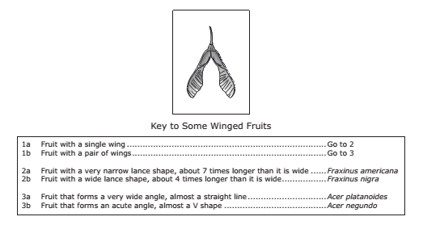
According to the key, the fruit comes from which species of tree?

A Fraxinus americana
B Fraxinus nigra
C Acer platanoides
D Acer negundo

15. Most plant leaves take in more carbon dioxide as light increases. They give off carbon dioxide if light intensity is too low. The graph shows a plant’s carbon dioxide levels at different light intensities.
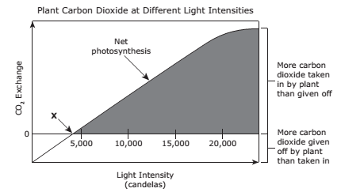
At point X, the rate of which process is equal to the rate of photosynthesis?

A Cellular respiration
B Transpiration
C Growth
D Reproduction

