_____1. Twenty cuttings were taken from one plant and planted in four containers of sand. Two containers had a pH of 6.0, and two had a pH of 8.0. When the cuttings matured, all of those grown in a pH of 6.0 had pink flowers, and all of those grown in a pH of 8.0 had blue flowers. One explanation for these results is that the sand at one pH contained a dye that changed the flower color. The best alternative explanation for these results is that:
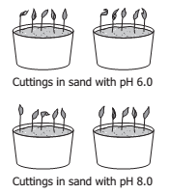
A the difference in pH caused the genes for flower color to be expressed differently
B a mutation occurred in the plant before the cuttings were taken and caused the difference
C by mistake, the scientist took some cuttings from the wrong plant
D by random chance, different flower colors developed on the plants grown at different pH
_____2. A student hypothesizes that green algae will grow fastest when exposed to blue light. To test this hypothesis, the student should design an experiment with which independent variable?
A Color of algae
B Rate of algae growth
C Color of light that algae are exposed to
D Amount of time per day that algae are exposed to light
_____3. One student in a class becomes sick with a fever and cough. Two days later, three other students in the same class become sick with the same symptoms. This is evidence that the illness is most likely caused by —

A cold weather
B a pathogen
C a genetic mutation
D nutritional deficiencies

_____4. The map shows where woolly mammoth and Columbian mammoth fossils have been found in North America. What kind of information does this map provide for paleontologists?
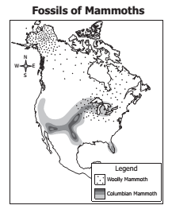
A The range of each mammoth species
B The seasonal migration routes of mammoths
C Where mammoths were most hunted
D Where mammoths moved as the climate changed
_____5. The graphs show the results of two separate experiments on the same species of plant. Students now want to determine how the use of rainwater or bottled water affects the growth of this plant. Which conditions should be used for optimal growth as the two water types are tested?
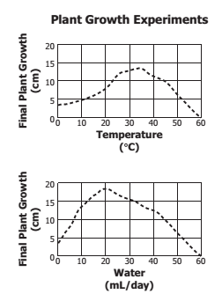

A 20°C, 10 mL/day
B 25°C, 35 mL/day
C 30°C, 45 mL/day
D 35°C, 20 mL/day

_____6. This food chain can be found in the coastal waters of Virginia. The population of which organisms in the food chain would be the first to decline if commercial fishing over-harvested shrimp?
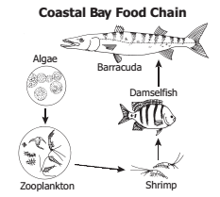
A Algae
B Zooplankton
C Damselfish
D Barracuda

_____7. Many Northern Hemisphere birds respond to seasonal environmental changes by:

A hibernating
B mutating
C migrating
D estivating

_____8. The picture shows a student’s experiment with Elodea, a common aquatic plant. Which change in this experiment is most likely to increase the volume of oxygen gas that accumulates in the top of the tube?
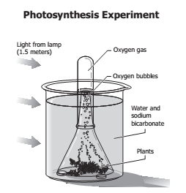

A Use fewer plants
B Replace the beaker with a larger container
C Move the light source closer to the beaker
D Reduce the amount of water

_____9. Which of these is required for aerobic cellular respiration?

A Carbon dioxide
B Sunlight
C Oxygen
D Chlorophyll

_____10. In a typical animal cell, which component contains the greatest amount of water?

A Cell membrane
B Cytoplasm
C Ribosomes
D Nucleus

_____11. The diagram shows a section of a cell membrane that includes a channel protein. The function of this protein is to:
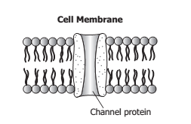
A strengthen the outer boundary of the cell
B connect reproductive cells during fertilization
C allow certain substances to enter or leave the cell
D exchange organelles or chromosomes between specialized cells

_____12. Under a microscope, a series of cells are observed that lack membrane-bound internal organelles. Which of these is the most likely cell type?

A Plant cell
B Animal cell
C Eukaryotic cell
D Prokaryotic cell

_____13. Which of these supports the cell theory as it is stated today?

A New cells are produced by division of existing cells.
B All organisms are composed of more than one cell.
C Cells must contain a nucleus.
D Not all cells are alive.

_____14. A student observes that a type of eubacteria contains chlorophyll. Which of these does this type of bacteria have in common with plants?

A It is photosynthetic.
B It contains vascular tissues.
C It contains mitochondria.
D It is heterotrophic.

_____15. In eukaryotic cells, the process indicated by arrow A occurs in the:
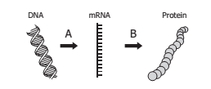

A cytoplasm
B ribosome
C nucleus
D cell membrane

