_____1. An iodine solution is placed on the cut side of a potato. Within seconds, a blue-black color appears. What is most likely occurring?

A a positive test for proteins
B a positive test for starches
C a negative test for proteins
D a negative test for starches

_____2. A person with swollen gums rinses his mouth with warm salt water, and swelling decreases. Which has occurred?
A The swollen gums have absorbed the saltwater solution.
B The saltwater solution lowers the temperature of the water in the gums.
C The salt in the solution has moved against the concentration gradient.
D The water in the gums has moved from a high to a low concentration of water.
_____3. The opossum, which is native to North America, and the kangaroo, which is native to
Australia, are marsupials.
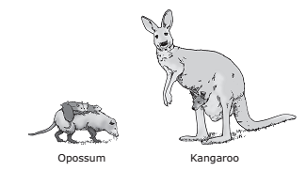
The fact that both these mammals incubate their immature offspring in a pouch provides evidence that they —

A belong to the same species
B must range great distances to eat
C have very similar skeletal structures
D are descended from a common ancestor

_____4. Sexual reproduction in animals depends on the production of gametes. Which of these processes produces gametes in animals?

A Mitosis
B Fertilization
C Meiosis
D Binary fission

____5. What two human systems work together to provide body cells with a constant supply of oxygen while removing carbon dioxide waste products?

A Nervous and endocrine
B Muscular and skeletal
C Respiratory and circulatory
D Excretory and integumentary

_____6. The cladogram shows the evolution of land plants as indicated by fossil records.
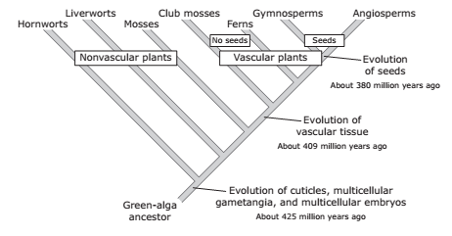
Which discovery would challenge the validity of this cladogram?
A A large aquatic vascular plant about 200 million years old
B A species of algae that has existed for less than one million years
C A moss species that has existed for less than 380 million years
D A fossil of a fern more than 425 million years old
_____7. Using a light microscope, a student identified the following characteristics of four organisms found in a sample of pond water.
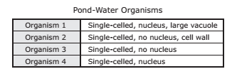
Based on the observations of the student, which organisms most likely belong to the taxonomic group for bacteria?

A Organisms 1 and 2
B Organisms 3 and 4
C Organisms 1 and 4
D Organisms 2 and 3

_____8. The sequence of nitrogenous bases in DNA varies widely. The sequence of the bases in DNA is most important for which of the following?
A Providing the instructions for the traits of an organism
B Preventing mutations from occurring during DNA replication
C Allowing the DNA to have the shape necessary for replication
D Helping form the sugar-phosphate backbone of DNA molecules
_____9. A marine ecosystem is represented below.
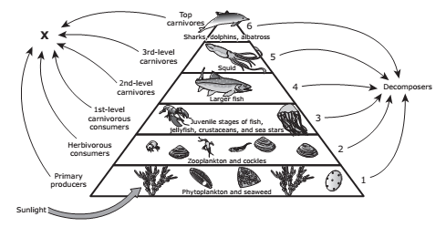
What is lost to the environment at each of the trophic levels of this ecosystem?

A Nutrients from the soil
B Living space for the organisms
C Food sources
D Heat

_____10. Four different types of cells are shown below.
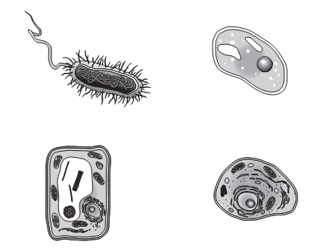
Which characteristic is shared by all four cells?

A A mechanism for transforming sunlight into energy
B Self-locomotion
C Membrane-bound organelles that transport substances
D Genetic material composed of DNA

_____11. Checkpoints occur between the stages of the cell cycle. If a cell does not meet certain criteria at the end of a stage, it will not move to the next stage.
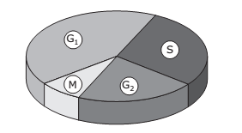
Which of these occurs just before the cell enters the G₂ stage of the cell cycle?
A The nuclear membrane disintegrates.
B DNA replicates.
C Centrioles form.
D The nucleolus divides.

_____12. In any environment or ecosystem, organisms can have several different types of relationships.
Three types of relationships are described below.
