_____1. The pedigree represents the occurrence of cystic fibrosis in four generations of a family.
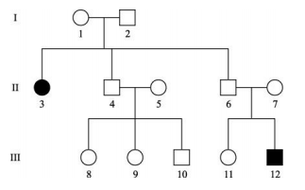
Which pattern of inheritance is shown?

A. autosomal recessive
B. sex–linked recessive
C. autosomal dominant
D. sex–linked dominant

_____2. The diagram below represents the karyotype for Klinefelter’s syndrome.
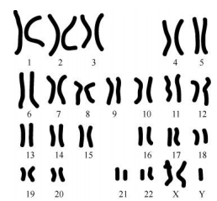
Which is the likely cause of this condition?

A. nondisjunction during mitosis
B. nondisjunction during meiosis
C. chromosomal deletion during mitosis
D. chromosomal deletion during meiosis

_____3. The human smallpox virus has been eradicated. Which describes how the smallpox vaccine worked?
A. Smallpox viruses invaded the vaccines rather than immune system cells.
B. Smallpox viruses were attacked by both the vaccine and the immune system.
C. Smallpox vaccines helped the immune system to create antibodies to the virus.
D. Smallpox vaccines synthesized a protective layer around immune system cells.

_____4. Which is the best explanation of the way enzymes speed up chemical reactions?

A. They raise activation energy.
B. They lower activation energy.
C. They maintain activation energy.
D. They have no effect on activation energy.

_____5. In which type of organism is a scientist likely to find the most cells containing a large vacuole?

A. bacterium
B. bird
C. fish
D. plant

_____6. A student constructs several terrariums like the one shown. Each terrarium is exposed to a different amount of sunlight each day. In order to determine the ideal amount of sunlight, which of the following variables must be held constant?
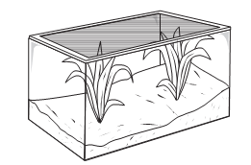

A Type of plants
B Growth rate of plants
C Wavelengths of sunlight
D Amount of sunlight received

_____7. The information in the table supports which conclusion?
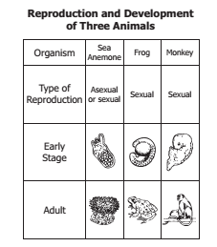
A Frogs are more closely related to monkeys than to sea anemones.
B Frogs, monkeys, and sea anemones are classified into different kingdoms.
C Sea anemones are more complex than frogs or monkeys.
D Sea anemones and monkeys are adapted to similar environments.
_____8. Bacteria adapt more quickly than elephants to environmental changes. Which best explains this difference?

A Bacteria reproduce more rapidly.
B Individual bacteria grow more steadily.
C Bacterial populations are more isolated.
D Individual bacteria have more genes.

_____9. A student looking through a light microscope saw this cell in cytokinesis. This cell is most likely from:
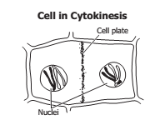

A a plant
B a virus
C an animal
D a bacterium

_____10. A geneticist studying fruit flies hypothesizes that short wings are a recessive trait coded for by a single gene. Which observation is most likely to have led her to form this hypothesis?
A Flies have wing lengths ranging from very long to very short.
B Flies with long wings are less likely to survive.
C Flies with long wings can produce offspring with short wings.
D Flies with short wings prefer to mate with flies with long wings
_____11. The diagram shows a setup for a plant investigation. Which variable is most likely being tested?
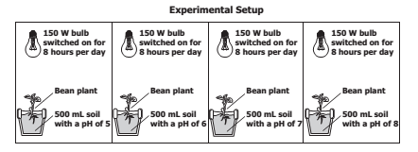

A Hours of light exposure
B Plant species
C Soil volume
D Soil pH

_____12. A population of mice is evenly divided into two groups, and each group is placed on an isolated island with no existing mouse population.
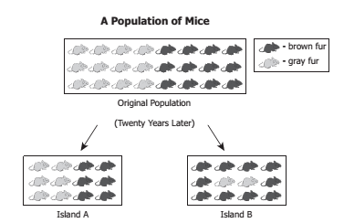
Which statement best explains the difference in the mouse populations on Island A and Island B at the end of the 20 years?
A On Island A, the allele for gray fur was dominant, while on Island B, the allele for brown fur was dominant.
B More brown mice were in the half of the original population that was sent to Island B than in the group sent to Island A.
C Conditions on Island B favored the brown-furred individuals, while both fur colors were evenly advantaged on Island A.
D The recapturing of mice on Island A and Island B was done differently.

