_____1. Which best describes an example of mutualism?
A. Mistletoe lives in the branches of tall trees, absorbing nutrients from the tree branch.
B. A leech attaches to the side of a fish, where it sucks blood and cell fluids from the fish.
C. A clown fish hides in the tentacles of a sea anemone, drawing larger fish to the anemone.
D. A barnacle attaches to the sides of a whale, filtering nourishment as the whale swims along.
_____2. In which way does mistletoe growing on a tree branch demonstrate parasitism?
A. The mistletoe absorbs water from the tree, but the tree is unaffected.
B. The tree is harmed or even killed, as the mistletoe takes nutrients from the tree.
C. The mistletoe grows around the tree, leaving the tree unaffected.
D. The tree supplies the mistletoe with nutrients, while the mistletoe provides the tree with water.
_____3. The graph shown tracks the sheep population in an area over 100 years.
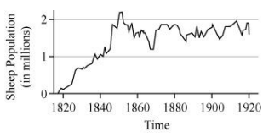
Which value is closest to the carrying capacity for this population?
A. 0.5 million sheep
B. 1.5 million sheep
C. 2.0 million sheep
D. 2.5 million sheep
_____4. Which graph best describes the relationship between trophic levels and available energy?
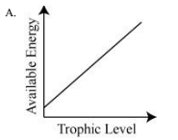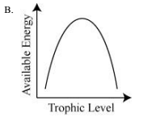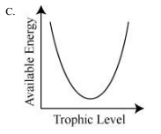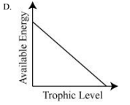

_____5. The diagram below shows the carbon dioxide levels in Hawaii from 1979 thru 2003.
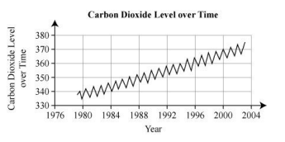
What is the most likely explanation for the annual fluctuations in carbon dioxide levels?
A. seasonal variation in people’s use of automobiles
B. seasonal variation in photosynthetic activity of plants
C. changes in the rate of deforestation in tropical regions
D. changes in wind currents that circulate the atmosphere
_____6. Which human activities have the greatest impact on the carbon cycle?
A. crop rotation and deforestation
B. cellular respiration and crop rotation
C. deforestation and burning fossil fuels
D. burning fossil fuels and crop rotation
_____7. Increasing carbon dioxide levels have contributed to the warming of Earth’ s atmosphere. Which best explains how deforestation has most contributed to the increase in atmospheric carbon dioxide?
A. by eliminating trees, which absorb and store carbon dioxide
B. by increasing soil erosion, which releases stored carbon dioxide
C. by decreasing the number of animals which release carbon dioxide
D. by replacing native trees with crops that do not absorb or store carbon dioxide
_____8. Beach vitex is a salt-tolerant plant that is native to Asia. It thrives in coastal dune systems and is a prolific seed producer. In 2010, the state of North Carolina banned the import, sale, and possession of this plant, which has been termed “the kudzu of the coast.”
The plant was most likely banned because of which effect?
A. toxicity to seagulls
B. erosion of the coastline
C. nuisance to beachgoers
D. outcompeting native grasses
_____9. Which is NOT a consequence of pesticide use?
A. birth defects
B. deforestation
C. biomagnification through food chains
D. resistance to pesticides from overexposure
_____10. Population growth in the United States has led to increased demand for nonrenewable resources. Which nonrenewable resources are most threatened in the United States?
A. sunlight, topsoil, and petroleum
B. freshwater, topsoil, and petroleum
C. forests, groundwater, and hydroelectricity
D. groundwater, topsoil, and hydroelectricity
_____11. The diagram below shows a farm that is located downstream from a chemical plant. The food web existing on the farm is also shown.
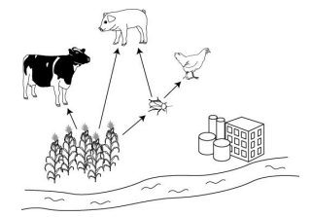
If a human wanted the lowest risk of chemical bioaccumulation, which organism should she choose to eat?

A. chicken
B. cow
C. pig
D. plant

_____12. An increase in Earth's average temperature from the buildup of carbon dioxide and other gases in the atmosphere is called
A. acid rain
B. ozone depletion.
C. greenhouse effect
D. particulate dispersal.

_____13. Which diagram shows the correct labeling of RNA molecules during the synthesis of polypeptides from amino acids and RNA?
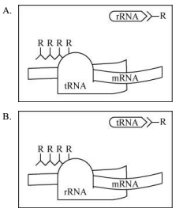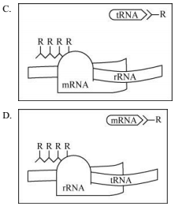
_____14. Two different samples of DNA are cut into fragments by the same restriction enzyme. The DNA is then run on a gel using electrophoresis.
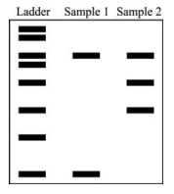
What is one reason why the two lanes of sample DNA are so different?
A. Sample 1 contained more base pairs than sample 2.
B. Sample 2 contained heavier base pairs than sample 2.
C. Sample 1 was cut too small by the restriction enzyme.
D. Sample 2 had more sites match the restriction enzyme.
_____15. How do scientists make transgenic plants resistant to a specific chemical pesticide?
A. by inserting genes into the plant’s DNA that code for pesticide-resistant proteins
B. by exposing the plants in the field to radiation to mutate their genes for resistance
C. by selectively cross-breeding different plants until a plant is produced that is resistant
D. by creating a symbiotic relationship between the plant and pesticide-resistant bacteria

