_____1. These three samples from the same live culture were all viewed at the same magnification. Which conclusion is best supported by the observation of these three samples?

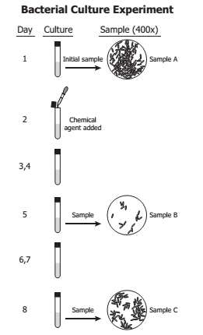

A The bacterial culture was unaffected by the chemical agent.

B The sampling techniques used did not produce accurate data.

C The culture became contaminated by airborne bacteria during the initial sampling.

D The culture included some bacteria that were resistant to the chemical agent.

_____2. Students research unicellular, prokaryotic organisms that live in harsh environments such as volcanic hot springs, brine pools, and anaerobic black organic mud. Which of these groups are the students mostlikely researching?

A Protista

B Archaebacteria

C Eubacteria

D Plantae

_____3. The diagram shows the normal sequence of genes in a particular chromosome. Which chromosome could have resulted from a deletion that occurred in this chromosome? 

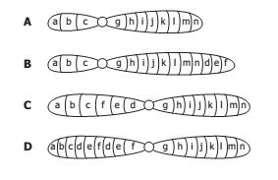

____4. Mrs. Smith has a baby named Tyra. She believes one of two men can be the father of her child. A paternity test is done and the results are shown below. Which of the 2 men could be the baby’s father?

1. Dad 1
2. Dad 2
3. Both dads could be the father
4. Neither dad could be the father

_____5. According to this fossil record chart, trilobites probably lived in what ancient environment?

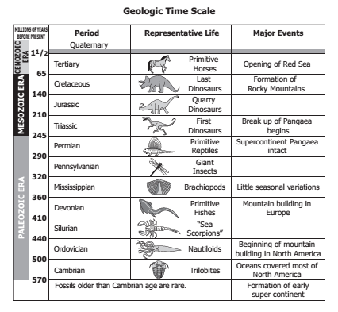

A Shallow seas

B Mountaintops

C Freshwater lakes

D Terrestrial forests

_____6. An early biological theory stated that a change in a population can occur when organisms with favorable variations for a particular environment survive and pass these variations on to the next generation. This theory is better known as the Theory of:

A Natural Selection

B Punctuated Selection

C Variation and Adaptation

D Acquired Characteristics

_____7. What ratio of the offspring from the cross shown will be homozygous recessive for the trait of tallness?

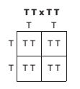

A 0 in 4

B 1 in 4

C 2 in 4

D 4 in 4

_____8. Based on this classification scheme, the European otter and the leopard are in the same:

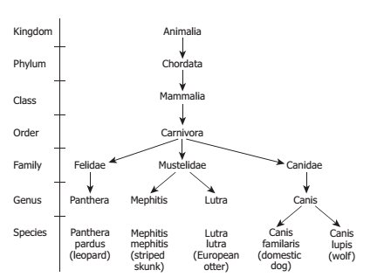

A kingdom but in different orders

B genus but in different species

C order but in different families

D family but in different genera

_____9. A scientist develops a hypothesis, designs an experiment, and obtains data that support her hypothesis. Which of the following best describes when a hypothesis becomes a theory?

A When one good set of scientific data supports a theory

B When the official scientific method is followed

C When a website is created to display the theory

D When it is supported by consistent data from many experimental trials

_____10. The different species of Hawaiian honeycreepers shown all descended from a single species of North American bird. They now have different beaks, eat different foods, sing different songs, and live in different environments on the islands. Which factor probably contributed most to the development of these different species?

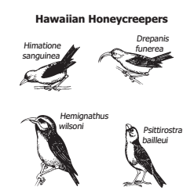

A Loss of habitat

B Geographic isolation

C Egg size

D Predation

_____11. What do viruses need to reproduce?

A Other viruses

B Host organisms

C A nutrient medium

D An enzyme solution

_____12. The interaction pictured represents:

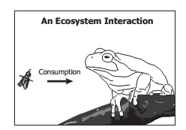

A growth

B respiration

C energy and nutrient transfer

D herbivory and decomposition